CIS2235 Java Programming I Program 6 150pts
Inheritance and Interfaces Group Project
Turn in requirements:
- 5 pts Please name your IntelliJ Project folder LastnameLastnameLastnameP6, such as NelsonCollinsBacaP6.
- 10 pts Upload your zipped project through the Brightspace Group Project.

Program Requirements:
- 5 pts Write your name, email address, program name and file name at the top of your source code in a comment
- 5 pts Use write your name, program title, and program objective as the title of the Frame.
- 5 pts Use good Java programming style and formatting for your program. Use appropriate comments to explain what you are doing.

We are going to write a program that starts with a model of a house and runs a hide and seek game throughout the house and its yards. Here is my model of the house and yards. You can see that it is pretty basic. You may use my model or create one of your own. But make sure that your model has the same features as mine, so the program will work.
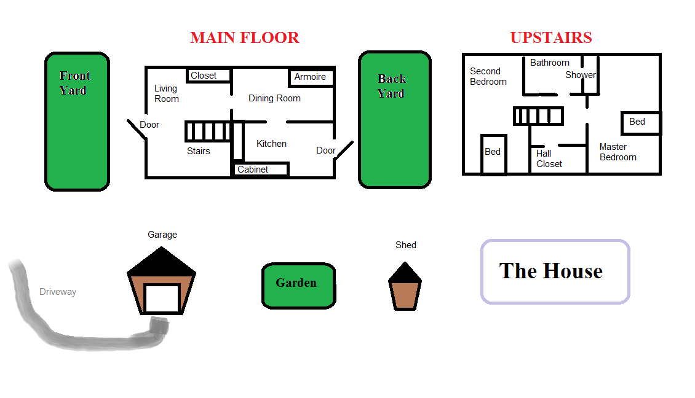

Step 1: The Model:

Every room or location in the house will be represented by its own object. The interior rooms will all inherit from the superclass Room and the outside places will inherit from the superclass Outside. Both Room and Outside are subclasses of Location, the super class.

Create an IntelliJ JavaFX project. Add the Location, Room and Outside classes to it. This is your super class, Location:

public class Location {
private String name;
private String description;

public Location(String name){
this.name = name;
}

public Location[] exits; //exits is an array of Locations that this location connects to

public String getName(){
return name;
}

public String getDescription(){
description = "You are standing in the " + name
+ ". \r\nYou see exits to the following places: ";

for(int i = 0; i < exits.length; i++)
{
description += "\r\n " + exits[i].getName();
if( i!= exits.length - 1)
description += ",";
}
description += ".\r\n";
return description;
}

}

The Room class adds a private class variable, String decoration, and its constructor has two parameters, String name and String decoration. It overrides the getDescription() method of the Location class by adding a String to it that says: "You see " + decoration + ". "

The Outside class adds a private class variable, boolean hot, and its constructor has two parameters, String name and boolean hot. It overrides the getDescription() method of the Location class by adding a String to it that says: "It's very hot." if the boolean hot is true.

The Form
Your Form should contain a title that describes the project and says how to start the game. It should have an image that shows the house, main floor and upstairs, the front and back yards, the garden with a shed and the driveway with a garage.

The house has four “rooms” on the lower floor, the stairs, a living room, a dining room and a kitchen. Upstairs, it has four “rooms”, the hall, the master bedroom, the second bedroom and the bathroom.
The living room has a door to the front yard and the kitchen has a door to the back yard.

You should also have a TextArea to display the progress of the game.
You need one Combo Box to display the choice of exits for each location.

There are five buttons to direct the game. You will need OnAction handlers for each button. Also, create fx:id’s for the buttons so you can set them to be visible or not as the game progresses.
- Hide button, which starts the game. It places the opponent, who is hiding and sets the initial location of the searcher ( the user).
- Go Here button, which will move the search to the Location displayed in the Combo Box.
- Go Through Door button, which will give the searcher an opportunity to go in/out of one of the two doors in the game. This move will take them to another Location.
- Check button, which will check the hiding place for the location (if any) listed in the Text Area to see if the opponent is hiding there.
- Exit the Game button, which will close out the game immediately.

There are interfaces and more classes to write.
The Interfaces:
- HasExteriorDoor, its methods are:
  - String getDoorDescription();
  - Location getDoorLocation();
  - void setDoorLocation(Location location);
- IsHidingPlace, its method is:
  - String getHidingPlaceName();

The rest of the classes that describe Locations in the game:
- class OutsideWithDoor extends Outside implements HasExteriorDoor
  - private variables for doorDescription and doorLocation
  - constructor has three parameters including doorDescription
  - getters for Door Description, Door Location
  - setter for Door Location
  - Override getDescription() method
- Class OutsideWithHidingPlace extends Outside implements IsHidingPlace
  - private variable for hidingPlaceName
  - constructor has three parameters including hidingPlaceName
  - getter for hidingPlaceName
  - Override getDescription() method
- class RoomWithHidingPlace extends Room implements IsHidingPlace
  - private variable for hidingPlaceName
  - constructor has three parameters including hidingPlaceName
  - getter for hidingPlaceName
  - Override getDescription() method
- class RoomWithDoor extends RoomWithHidingPlace implements HasExteriorDoor
  - private variables for doorDescription and doorLocation
  - getters for both private variables
  - setter for doorLocation
- class Opponent
  - private class variables for Random random and Location myLocation.
  - constructor that takes one parameter, starting Location
  - getter for myLocation
  - check method that is passed the locationToCheck and compares it with myLocation to see if the opponent has been found.
  - move method that randomly moves the opponent’s location. It checks if the current room has a door. If so, it has a 50% chance of going through it. Then it moves to a random location and keeps going until it finds a hiding place.

Finally, there is the Controller class that provides the interface between the user and the model classes. There are:
- @FXML variables for the TextArea, ComboBox and the 5 buttons
- @FXML OnAction handlers for each button
- method public void initialize()
  - Call createObjects()
  - Instantiate the opponent object and make the initial location the front yard.
  - Call resetGame(false);
- private variables
  - int to keep track of how many moves were used
  - Location object to keep track of current location
  - Opponent object to keep track of opponent
  - Object references to keep track of each of the rooms in the house, as described above. There are eight objects.
  - Object references to keep track of the outside locations. There are four of these objects.
- private methods
  - void createObjects().
    - Instantiate the classes and pass information about each room to each constructor
    - Populate the exits array for each room. We have to do this after we create all of the instances because we are going to refer to them. This is instantiating the array declared in the Location class, public Location[] exits; exits is an array of Locations that this location connects to.
  - void moveToANewLocation(Location newLocation)
    - increments number of moves
    - sets currentLocation to newLocation
    - calls redrawForm()
  - void redrawForm()
    - Since the location has changed, clear the Combo Box items.
    - Set the exit names corresponding to the current location into the Combo Box
    - Set the first exit to be displayed in the Combo Box
    - If the current location has a hiding place
      - Set the text on the Check button to display “Check “ + hidingPlaceName
      - Set the Check button to be visible.
    - If there is no hiding place, set the Check button to not visible.
    - If the current location has an exterior door,
      - Set the GoThroughTheDoor button to visible
    - If there is no door, set the button to not visible.
  - void resetGame(boolean displayMessage)
    - if displayMessage is true,
      - Display a message in a JOP that states how many moves it took to find the opponent (optional)
      - Display a summary in the TextArea of how many moves and the name of the location where they were found
    - In any case, reset the controls to play another game

P6 Grading Rubric:

Time Due: 3:30 PM on Thursday, March 17. 😊
Grade breakdown: 150 points total
10 pt You participate in demonstrating your project in class.
Your program must be running in order for this portion of the score.
20 pts (5 pts each) Successful coding and decoding of each of your 4 derived classes
5 pts Successful coding of the Opponent class
15 pts Your user interface is simple to use. You follow program specs as described here in this document
50 pts Successful coding of your 5 OnAction handlers
50pts Successful coding of your 4 Controller private methods and the initialize method

